**Quiz - Numeric Variables**

**Question 1**

Parte superior do formulário

**Fill in the missing words. Choose from: outlier, median, mode, mean, average, quartile.**

The value where our stacked dot plot or histogram balances is the **mean**. The middle value of the data is the **median** .

In statistics “Average” refers to the vague idea of “centre”. “Mean” and “Median” are precise, but different, ways of trying to implement the vague idea of “average”.

Parte inferior do formulário

**Question 2**

Parte superior do formulário

**The following statements refer to this plot of BPDiaAve (average diastolic blood pressure) from the NHANES-1000 data set.**

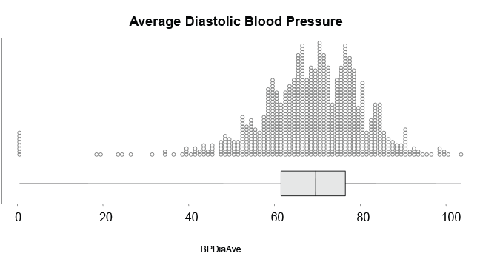

One of the statements is false. Select the **FALSE** statement.

The median diastolic blood pressure, **BPDiaAve**, is about 70.

Almost everyone had a **BPDiaAve** between 20 and 100.

**The mean for this data will be *very different* to the median, due to the shape of the dot plot.**

More than 75% of people have a **BPDiaAve** above 60.

Some people got a reading of 0 for their **BPDiaAve**.

**Correct**

This statement is **FALSE**. The dot plot and box plot is reasonably symmetric. The mean and median would be quite similar.

Parte inferior do formulário

**Question 3**

Parte superior do formulário

**The following statements refer to this plot of AlcoholDay (number of alcoholic drinks consumed per day) from the NHANES-1000 data set.**

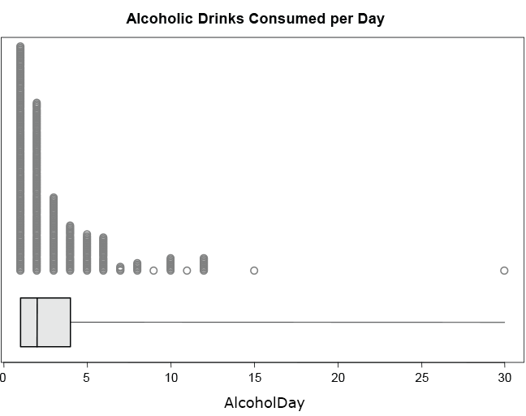

One of the statements is false. Select the **FALSE** statement.

The distribution of **AlcoholDay** is *strongly skewed*.

The vast majority of respondents reported 12 drinks per day or fewer.

**The median and mean of the number of drinks per day would be *very similar*.**

Everyone who answered this question had at least 1 drink per day.

About 75% of respondents report no more than 4 drinks per day.

**Correct**

This statement is **FALSE**. The data is strongly positively skewed.

Parte inferior do formulário